

Army Public School
S P Marg, Lucknow
2022-23
Computer Science Project
PROJECT NAME

NAME:- harshit Mishra
XII Science
BOARD Roll No :

Contents

- Acknowledgement

- Certificate

- System Requirements

- Synopsis

- Coding

- Screen Shots

- Bibliography

ACKNOWLEDGEMENT

I wish to express my thanks and immense gratitude to my project guide and supervisor Mr. Amit Trivedi under whose kind advices this project has been prepared.
His able guidance, valuable suggestions at various stages of the project has benefited in the completion of the same.
I also express my deep sense of gratitude to Ms Seema Tara (PRINCIPAL) for providing all facilities for the project work.

NAME: - Harshit Mishra
XII Science

CERTIFICATE

This is to certify that “Harshit Mishra” of class XII has completed this project titled “PROJECT TITLE” under my supervision. I certify that this project is up to my expectation and as per the guidelines issued by CBSE, and may be considered as part of the practical exam of AISSCE conducted by CBSE.

_________ _________
Mr. Amit Trivedi Ms Seema Tara
PGT Computer Science Principal
Army Public School Army Public School
S P MARG, LKO S P MARG, LKO

Certificate

This is to certify that “harshit Mishra” of class XII, Army Public School, Sardar Patel Marg Lucknow has successfully completed his/her project in computer practical’s as prescribed by CBSE in the year 2022-2023.

Date :

Board Roll No. :

Signature of Internal Signature of External
Examiner Examiner

__________________ __________________

System Requirments

- PLATFORM:
- Windows 11
- SOFTWARE:
- PYTHON IDLE 3.10
- MYSQL /8.1.0
- Microsoft Word 2019
- HARDWARE:
- Intel Core i3
- 4 GB RAM
- 1 TB Hard Disk
- 1366 x 768 Screen Resolution

SYNOPSIS

Project Description
Description: A library management system is software that is designed to manage all the functions of a library. It helps librarian to maintain the database of new books and the books that are borrowed by members along with their due dates. This system completely automates all your library's activities.

MODULES
Mysql. Connector
Cursor()
Execute()
Addbook()
Commit()
Main()
Bookup()
Issueb()
Submitb()
Fetchone()
Rbook()
Dispbook()
Fetchall()
Ibooks()
Exit()
Passwd()

DATABASE NAME:
LMS
Table Name:
1. Books
2. Issue
3. Submit

Coding

import mysql.connector as a
con = a.connect (host="localhost",user="root",passwd="sql",database="lms")

def addbook():
bn = input("Enter BOOK Name : ")
c = input("Enter BOOK Code : ")
t = input("Total Books : ")
s = input("Enter Subject : ")
p= input('Enter the price of the book:')
z = input("Enter Author of book: ")
data = (bn,c,t,s,p,z)
sql = 'insert into books values(%s,%s,%s,%s,%s,%s)'
c = con.cursor()
c.execute(sql,data)
con.commit()
print(">----------------------------------------------------------------------------------------<")
print("Entries Updated Successfully")
main()

def issueb():
n = input("Enter Name : ")
r = input("Enter Reg No : ")
co = input("Enter Book Code : ")
d = input("Enter Date : ")
a = "insert into issue values(%s,%s,%s,%s)"
data = (n,r,co,d)
c = con.cursor()
c.execute(a,data)
con.commit()
print(">--------------------------------------------------------------------------------------------<")
print("Book issued to : ",n,'successfully')
bookup(co,-1)

def submitb():
n = input("Enter Name : ")
r = input("Enter Reg No : ")
co = input("Enter Book Code : ")
d = input("Enter Date : ")
a = "insert into submit values(%s,%s,%s,%s)"
data = (n,r,co,d)
c = con.cursor()
c.execute(a,data)
con.commit()
print(">--------------------------------------------------------------------------------------------<")
print("Book Submitted from : ",n,'successfully')
bookup(co,1)

def bookup(co,u):
a="select TOTAL from books where BCODE = %s"
data=(co,)
c=con.cursor()
c.execute(a,data)
myresult=c.fetchone()
t=myresult[0]+u
sql="update books set TOTAL = %s where BCODE = %s"
d=(t,co)
c.execute(sql,d)
con.commit()
main()

def rbook():
ac = input("Enter Book Code : ")
a = "delete from books where BCODE = %s"
data = (ac,)
c = con.cursor()
c.execute(a,data)
con.commit()
print('Entry deleted successfully')
main()

def dispbook():
a = "select * from books"
c = con.cursor()
c.execute(a)
myresult = c.fetchall()
for i in myresult:
print("Book Name : ",i[0])
print("Book Code : ",i[1])
print("Total Books : ",i[2])
print("Subject : ",i[3])
print("Price(in INR) : ",i[4])
print(" Author of book: ",i[5])
print(">--------------------------------<")
main()

def ibooks():
a = "select * from issue"
c = con.cursor()
c.execute(a)
myresult = c.fetchall()
for i in myresult:
print("Student Name : ",i[0])
print("Reg No : ",i[1])
print("Book Code : ",i[2])
print("Issue Date : ",i[3])
print(">--------------------------------<")
main()

def main():
print("""
LIBRARY MANAGEMENT SYSTEM
( BUILT BY ABHINAV AND HARSHIT )

1. ADD
2. ISSUE
3. SUBMIT
4. REMOVE
5. DISPLAY
6. EXIT
""")
choice = input("Enter Task No : ")
print(">--------------------------------------------------------------------------------------------<")
if (choice == '1'):
addbook()
elif (choice=='2'):
issueb()
elif (choice=='3'):
submitb()
elif (choice=='4'):
rbook()
elif (choice=='5'):
print("1. All 2. Issued")
ch = input("Enter Task No. ")
print(">--------------------------------------------------------------------------------------------<")
if ch == '1':
dispbook()
else:
ibooks()
elif (choice=='6'):
exit()
else :
print(" Wrong choice..........")
main()

def paswd():
ps = input("Enter Password : ")
if ps == "sql":
main()
else:
print("Wrong Password")
paswd()
paswd()

Screenshots
Database tables:

1.Books

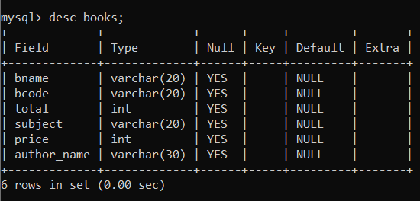

2.Submit
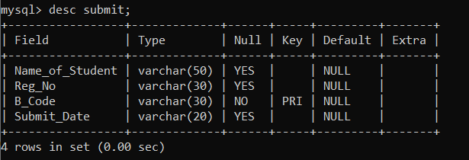

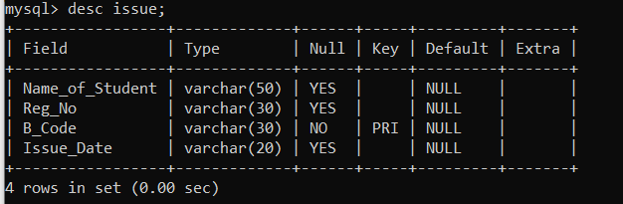
3.Issue

Screenshots
python OUTPUT windows:

- 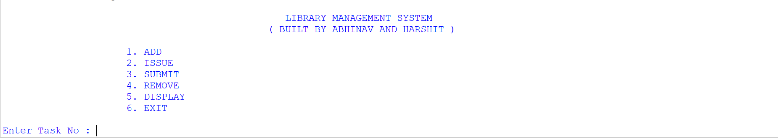

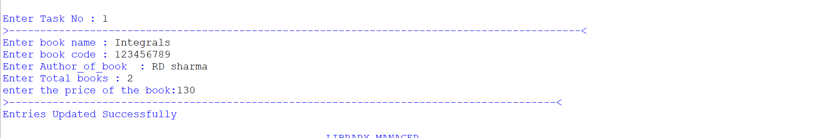

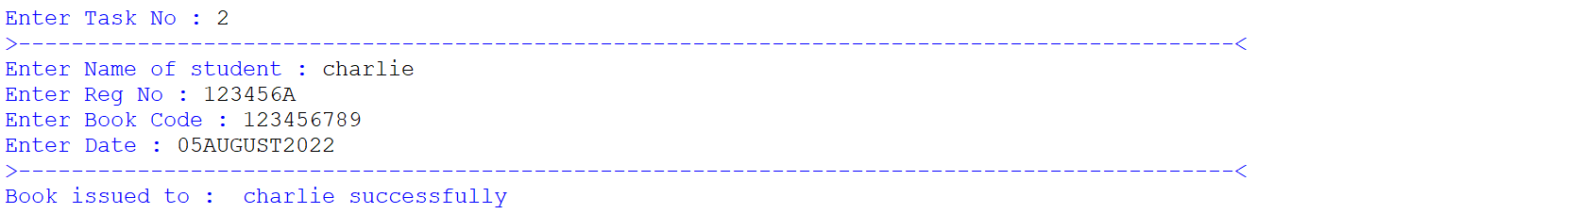

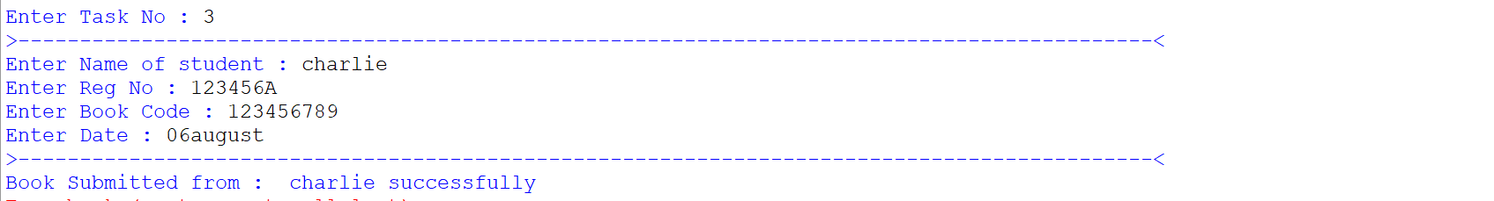

Bibliography

- Books
- Computer Science Class 12 Textbook By Preeti Arora

- Websites
- www.cbse.nic.in
- www.python.org

